Exercise 1: Sum Adjacent Equal Numbers
Write a program to sum all adjacent equal numbers in a list of decimal numbers, starting from left to right.
Examples:
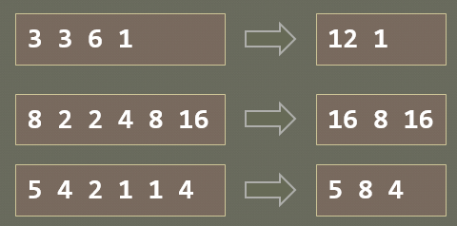

Exercise 2: Gauss' Trick
Write a program that sum all numbers in a list in the following order:
first + last, first + 1 + last - 1, first + 2 + last - 2, … first + n, last – n
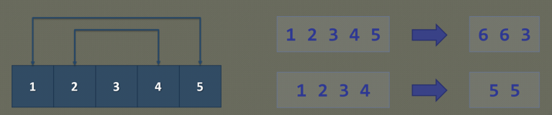

Exercise 3
- Define a class Student, which holds the following information: ID, Name and Age.
- Create a list of students
- Sort the list by Name and print it.

Exercise 4: Cars
NOTE: You need a public StartUp class with the namespace Cars.
Build a hierarchy of interfaces and classes:
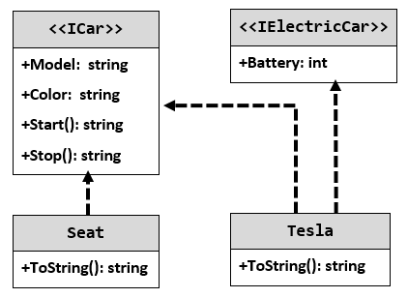
Your hierarchy must be used with this code:
StartUp.cs
ICar seat = new Seat("Leon", "Grey");
ICar tesla = new Tesla("Model 3", "Red", 2);

Console.WriteLine(seat.ToString());
Console.WriteLine(tesla.ToString());

Examples
Output
Grey Seat Leon
Engine start
Breaaak!
Red Tesla Model 3 with 2 Batteries
Engine start
Breaaak!

